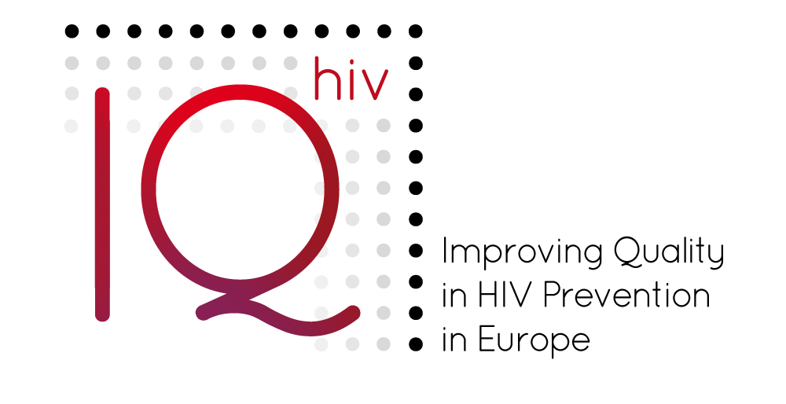
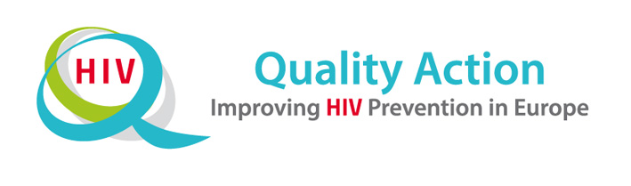

THE MMSM-PROJECT:
OUTREACH FOR MIGRANT MSM

Succeed
A CASE EXAMPLE ON HOW THE
QUESTIONS CAN BE ANSWERED
Background
Although based on real projects, this example on QI from a project on outreach for migrant men who have sex with men is not a true story. It has been developed and made anonymous with the purpose of helping users to understand how Succeed questions can be answered.
The Succeed tool has been updated since this case example was written. The case example has also been updated accordingly. However, there can still be slight differences between the Succeed tool in its current version and this example. The differences should not matter regarding the relevance and purpose of the case example.

For many years M-ville, the capital of a European country, has received proportionally large groups of gay men and men who have sex with men (MSM) from other countries. Many come from all over Europe and others come from the Middle East as well as from Asia, mostly Thailand. Some of these men come from countries where they have led a hidden life and had little access to adequate HIV prevention. Some come from high prevalence countries. All of them have difficulties in accessing HIV prevention services, testing and treatment because they are in a new country. In spite of this, there are no specific outreach activities to target these men. NGOs maintain that they are reached by general outreach in gay bars, clubs, video parlours, parks and through websites.
The MMSM-project
A group of five experienced and bilingual volunteers doing the ‘regular’ outreach work decide to form their own NGO for targeted outreach to newly-arrived migrant MSM. They apply for and obtain funding for up to three years to do the following:
- Design outreach methods and content for group homes, language schools and gay bars
- Recruit at least 10 bilingual volunteers
- Perform regular outreach
- Start a phone line in Arabic, Spanish, French and English (their own language skills)
- Start a small website with information in these languages and important links
After six months, they are encouraged by the funder to use Succeed to help them to prioritise their aims. Below you will find their answers.
How the MMSM project team answered the questions in Succeed and their plans to improve the quality of their project
STRUCTURE OF THE PROJECT

Goals
- Have you set overall goals for the project?
[Yes / No]
If yes, what are they?
Raised awareness and knowledge about HIV/STI and hepatitis C prevention and treatment options among migrant MSM from the Middle East.
- What do you want to achieve with the project?
To ensure that MSM in the Middle Eastern migrant community in our city have access to prevention and services on STI, HIV and hepatitis.
To involve MSM from this migrant community in HIV prevention.
- Have you developed objectives or sub-goals for the project?
[Yes / No]
If yes, what are they?
1 To develop a website and a telephone hotline.
2 To identify more MSM activists in the Middle Eastern migrant community.
3 To conduct a range of outreach activities.
- Are the goals clear and concise enough for you to measure the project’s performance?
[Yes / No]

Next steps:
- What actions do you need to take?
We will make the sub-goals for the outreach activities more specific: X number of MSM reached in the first year, Y number in the second year and Z number in the third year.
We will also decide how many new volunteers we want to recruit and train.
We will measure to what extent our website is reaching the right people.
- Who will take them?
The Project Manager and a member of the volunteer team will work with the project team and the board to clarify our sub-goals.
- When will they take them?
Ready for discussion in two months.

Key Population(s)
- What key population(s) does the project reach and/or plan to reach?
Middle Eastern MSM who are first-generation migrants are our first target group; then we will move on to MSM from Latin America and Africa.
- Do/did you have specific reasons for selecting this group or groups?
[Yes / No]
If yes, what are/were your reasons for selecting this group or groups?
Over the last eight years, a large group of refugees (around 100,000) have arrived in our city from the Middle East. We know that some obtained their right to stay in our country because they are gay and are denied their human rights as gay men in their country of origin. Until recently, these men have been rather passive about participating in the gay community, voicing their concerns and working with HIV prevention NGOs. These men often lead clandestine social lives, not having been able to access a gay scene in their countries of origin. They need information on how to protect themselves from HIV infection since they now live in a country where they can more easily find sexual partners.
- Did you use any data or other information to make your selection?
[Yes / No]
If yes, please provide a brief description of the data that was used.
Data on the numbers of migrants and asylum seekers from Middle Eastern countries, including how many there are and where they live in the city. Data on the number of people infected from these countries. Supporting information from members of the project team, who have all been members of other outreach projects and found that these projects have not managed to reach MSM in this population in a meaningful way.
Are you reaching or planning to reach this key population directly with your project?
Yes / No
If no, are you targeting intermediaries or others and why?

Next steps:
- What actions do you need to take?
[Open-ended response]
- Who will take them?
[Open-ended response]
- When will they take them?
[Open-ended response]

Approach
- Is there an overall outline or plan for your approach?
[Yes / No]
- Have you documented the different components of the approach?
[Yes / No]
- Can you identify the strengths and weaknesses of the approach?
[Yes / No]
If yes, what are they?
We can identify some strengths and weaknesses but probably not all of them.
Strengths:
1 The members of the project team are all multilingual and have good contacts in their target communities and in the society at large.
2 We have experience with outreach activities and team members with good communication skills (building websites, using social media, etc.)
3 We have 40 existing contacts from previous work.
4 We have already recruited two volunteers.
Weaknesses:
1 Our goals are not clear enough and they are too broad.
2 We have not phased our activities properly.
3 Our organisation is new and the project team is new.
4 Our outreach activities are not clearly structured and documented.
- Does the approach include any plans for regular quality management?
[Yes / No]
If yes, how – and how often – will you assess the quality of the project?
This is required by our funder. We are committed to an annual assessment and would possibly do it more often if it is useful.
- What will you do with the findings from any quality management activities?
We will use them to make the necessary changes. If many are needed, we will prioritise them. We will also feed the most important results into our yearly report to the board and the funder.
- Could the project activities have negative effects for anyone??
[Yes / No]

If yes, what are they?
Many of the people we want to approach might prefer to keep their sexual orientation private. Their preference has to be respected. If we do not carefully maintain confidentiality, we could cause problems for people in our target groups and lose their trust.

Next steps:
- What actions do you need to take?
We will prioritise the necessary improvements and include them in our plans.
We will raise topic of HIV/STI in a general manner when we approach community groups and then leave cards with contact information.
We will assure people of our discretion and respect for their privacy.
We will take a professional approach on the hotline.
We will structure our outreach better (preparation, activities and follow-up) and, for use by our volunteers, write up a simple manual that clearly states our main messages.
We will consider these measures in our information materials and in the training for people working the telephone hotline.
Also, ethics will be a permanent item on the team’s meeting agenda.
- Who will take them?
1 Project Manager
2 One member of the project team will take the lead on ethical issues and review all project components from an ethical perspective.
- When will they take them?
Item to be considered at every team meeting (every two weeks).

Responsibility
- Who decided to initiate the project?
The board.
- Does the project have the necessary backing from key stakeholders and decision makers?
[Yes / No]
If no, why don’t you have this backing from them?
We are not sure what the other players on the MSM scene think about this initiative. However, we have obtained funding for a possible three-year project.
- Is the division of responsibility clear between the project management team and others in the decision-making hierarchy?
[Yes / No]

Next steps:
- What actions do you need to take in order to clarify the lines of responsibility?
We must contact the main stakeholders and clinics and present our project to them.
- Who will take them?
The Project Manager will make contact and set up meetings.
- When will they take them?
Over the next six months.

Organisation
- Is this project run as a ‘stand-alone’ project with its own staff or is it run by a ‘parent organisation as one of several activities?
[Stand-alone project / Parent organisation]
- If it is run by a parent organisation, is the project clearly delineated from its other activities?
[Yes / No]
- Have you made decisions about the organisational structure of the project?
[Yes / No]
- Have you selected a Project Manager?
[Yes / No]
- Does the Project Manager have a clear and complete understanding of his/her authority and areas of responsibility?
[Yes / No]
- Are all of the other people involved in the project clear about their roles and responsibilities?
[Yes / No]
- Is there a realistic time plan for the project?
[Yes / No]
- Have you set aside a realistic amount of time for everyone involved to complete their tasks?
[Yes / No]

Next steps:
- What actions do you need to take to strengthen how the project is organised?
We will clarify the roles in the project team and divide tasks in a better way in order to utilise our different strengths. We will phase our intervention better as well as outline specific activities for each phase and then divide them between us.
- Who will take them?
The Project Manager will prepare an outline of the actions and the entire project team will have a specific planning meeting to discuss the next steps.
- When will they take them?
At the next meeting.

Resources
- Do you have sufficient financial resources to do the work of the project?
[Yes / No]
If no, what are the specific components of the project that are under-funded?
The website. This is why we opted for a very simple site.
- Do you have enough people (both staff and volunteers) to do the work?
[Yes / No]
If no, where you would need more people?
We need more time from the members of the project team to staff the hotline and do the outreach work. Or we need to recruit more people to help with our activities. We also need people to help with the information materials, the website, meetings with stakeholders and working with new volunteers.
- Do you have adequate facilities to do the work?
[Yes / No]
If no, what additional facilities do you need?
We have one room in a community house where meeting rooms are available. This is OK for now but in the long run we might need a more discreet place to meet.
- Does the project staff have a role in determining how project resources are used?
[Yes / No]
If yes, can they reallocate resources to adapt to changing needs and/or circumstances?
Yes, up to 1000 Euro. Otherwise, a board decision is required.
- Do staff and volunteers have sufficient knowledge about the work of the project to be effective?
[Yes / No]
- Is training available for staff and volunteers?
[Yes / No]
- Have you set aside funds in the budget for future training needs?
[Yes / No]

Next steps:
- What actions do you need to take to ensure you are properly managing your resources?
Adapt our ambitions to our resources. We did not obtain all the funds we applied for and we need to adjust our plans.
- Who will take them?
A revised plan has already been drafted and submitted to the board and also to the funders.
- When will they take them?

THE PROJECT PROCESS

Support/participation
- List the key project stakeholders (e.g. organisations and individuals) and identify their roles in the project (e.g. advisory, funding, planning, implementation, advocacy, assessment).
Funder – advisory, Gay clubs and pubs – implementation, Main gay internet site – implementation, Local gay and lesbian association – implementation, Gay+ – implementation, Migrants’ associations for different countries – implementation, Language schools for migrants – implementation, Local employment authority responsible for the reception of new migrants – advisory.
- Does each of the stakeholders understand and agree with the goals of the project?
[Yes / No]
If no, who does not agree and why not?
We did not have all stakeholders on board for the proposal. We are currently contacting them to discuss their possible role and how we can work together.
- Do all the relevant stakeholders have an opportunity to participate in: -the planning of the project?
[Yes / No]
- Do all the relevant stakeholders have an opportunity to participate in: -the implementation of the project?
[Yes / No]
- Do all the relevant stakeholders have an opportunity to participate in: -the monitoring of the project?
[Yes / No]
- Do you know if the stakeholders feel they are active participants in the project?
[Yes / No]
- Does the project have the ability to track the extent of stakeholder participation?
[Yes / No]
If yes, briefly describe how this tracking is done.
This has not been done yet but is very possible. When someone agrees to become a stakeholder, we will record their participation in meetings and activities.
- Have stakeholders made formal commitments about their participation in the project?
[Yes / No]
- Are there contracts or agreements between the project sponsor and the stakeholders (e.g. between the project sponsor and an implementing partner)?
[Yes / No]
If yes, briefly describe one example.
Our signed project plan is the basis of receiving funding. We have agreed to activities such as revising the budget and regular quality improvement.
- Is there a minimum level of participation required for stakeholders to stay involved in the project?
[Yes / No]
- Are there any economic relationships between the project and key stakeholders? Does the project receive or distribute funds to stakeholders?
[Yes / No]
If yes, are there clear agreements on how economic relationships should work?[Yes / No]
Are stakeholders generally well informed about the project?
Don’t know/ few/some most/all
- Are there regular mechanisms for communicating with stakeholders?
[Yes / No]
If yes, what are the mechanisms? [ For example: Email, Newsletter, Meetings, Annual Report, Other]
- Has the project analysed potential obstacles and/or opponents to its work? (Please describe possible obstacles on the general/societal level, in the local community, in the organisation or on the individual and group level.)
[Yes / No]

Next steps:
- What actions do you need to take?
We will increase stakeholder participation and consider using agreements to structure their participation more.
We will distribute a short, monthly newsletter to stakeholders.
We will analyse obstacles and include them in our planning as well as report them to the funder.

- Who will take them?
The Project Manager will draft an information sheet on our activities and how we would like to cooperate with stakeholders. He will also draft a standard agreement for stakeholders.
The web editor will put together a mailing list and a monthly, electronic information newsletter.

- When will they take them?
The project team will review obstacles to our work at our next meeting. Within three weeks.

Network
- Does the project have “networks”?
[Yes /No]
- If yes, do you have a list of all member organisations in the network?
[Yes / No]
- Do you have a list of all relevant individuals in the network(s)?
[Yes / No]
- Are important organisations and individuals missing from the network?
[Yes / No]
If yes, what/who are they?
It is hard to say who and what is a relevant organisation or individual. We know the people who are or want to be active and they are the most relevant. However, we do not yet have a list of all possible organisations that could be part of our network.
- Do the network(s) have the opportunity to assess their work on the project?
[Yes / No]
If yes, have any such assessments of the networks taken place or are any planned for the future? [Yes / No]
- Are there opportunities for networks to build their capacity to participate in the project?
[Yes / No]
- Have you set aside resources in the project for training network members?
[Yes / No]
- Does the project encourage and support ‘enthusiasts’ (i.e. committed and active advocates/supporters/volunteers) of the project?
[Yes/No]
- If yes, describe briefly
We have not yet considered working with these people but realise that we must do so in the future. We may include such things as giving small gifts and having a party for volunteers as well as extending invitations for special educational sessions or for representing our organisation at a conference.

Next steps:
- What actions do you need to take?
We will outline who we would like our intended network to include and consider how to build this network.
We will write different lists of present and potential collaborating partners and persons to contact for different purposes.
We will also discuss at our next project meeting how to support enthusiasts.
- Who will take them?
A member of the project team will make a proposal about what an ideal network would look like and then compile the necessary list of contacts.
- When will they take them?
The outline will be ready in two weeks.

Reach and response
- Can you measure whether the project is reaching the key population(s) that are the ultimate beneficiaries of the work?
[Yes / No]
If yes, how is this done?
We estimate that 3% of the male population are MSM (according to research in our country). The research also tells us about their preferences for insertive and/or receptive anal intercourse. We are trying to measure how many MSM we reach and in what way.
- If the project can measure whether its efforts are reaching the key population(s), can you determine what percentage of the population(s) is being reached?
[Yes / No]
If yes, what is that percentage and how is it determined?
At the moment, the percentage is very low, around 3%. We keep track of how many people we contact through our various organisations. We also have an estimate of the total number of people we are trying to reach.
- Can you determine how key populations respond to the project’s efforts? For example, do the key populations understand the primary prevention message(s)? Do key implementers understand the strategic approach of the project?
[Yes / No]
- If your project is designed to reach intermediary target groups, can you determine what percentage of these groups are being reached? \
[Yes / No]
- Can you determine how the intermediary target groups respond to your message or measures?
[Yes/ No]

Next steps:
- What actions do you need to take?
We will develop simple tools to measure how well our communications are understood. Options are a survey on our website and a small questionnaire to use after workshops with the target group or with groups that we expect to include members of the target group.
- Who will take them?
A member of the project team, who is a student at the School of Social Work, will draft a survey and consult his sociology professor.
- When will they take them?
The survey will be ready in two months.

RESULTS OF THE PROJECT
- Does the project measure whether the knowledge, attitudes and/or behaviour of key population(s) have changed over time?
[Yes / No]
- Are the changes in knowledge, attitudes and/or behaviour among the key population(s) (and/or intermediary target groups) in line with the project’s goals?
[Yes / No]
If no, why not? (e.g. limited capacity, limited resources)
There are problems getting baseline data to track these changes. We do not currently know how these data could be collected. We can only measure how many people we meet, whether they understand our message and if their awareness and knowledge increases.

Next steps:
- What actions do you need to take?
We need a proper consultation with someone who can advise us on how to monitor changes in knowledge, attitudes and behaviour in the target group, if this is at all possible. The Project Manager will contact the funder to get their advice on who could help us.
- Who will take them?
The Project Manager.
- When will they take them?
The Project Manager will write to the funder this week.

Environmental, operational and social changes
- Does the project track the outcomes and/or impact of its work more broadly? (e.g. knowledge, acceptance, reduced stigma and discrimination, obstacles to the provision of services, availability of services, range of service options, legislation, availability of funding) [Yes / No]
If yes: How do you track these changes? (e.g. surveys, special studies, national statistics)
Everyone in the team keeps a project diary where changes are noted.
- Are the changes moving the project towards its goal?
[Yes / No]
If the project does not track the broader outcomes and/or impact of its´s work, why not? (e.g. limited capacity, limited resources)
Too early to tell. However, we have had a positive response from the local authorities so far.

Next steps:
- What actions do you need to take to improve measuring and highlighting the results of your project?
Keep on recording changes and follow them up at project meetings.
- Who will take them?
The Project Manager will put this topic on the agenda for the next meeting.
- When will they take them?
At the next project meeting.

Sustainability
- Does the project have an end date?
[Yes / No]
If yes, is there a need for the project to continue beyond the end date? [Yes / No]
Don’t know.
- Are the project activities sustainable in the long run? [Yes / No]
Unclear.
- Have you taken steps to ensure its sustainability?
[Yes / No]
If no, why not?
It is absolutely unclear what might happen to the project in the long run. Much too early to tell.

Next steps:
- What actions do you need to take?
Put sustainability issues on our long term planning list.
- Who will take them?
We do not know yet.
- When will they take them?
We do not know yet.

