
QUALITY ACTION POLICY KIT

Policy kit for public health officials and advocates involved in policy and programming for HIV prevention and related public health challenges.

Quality Action is the European Joint Action on improving Quality in HIV prevention (2013-2016) co-funded by the European Commission. Governmental Organisations and Non-Governmental Organisations in 25 countries contributed as partners (www.qualityaction.eu)

QUALITY IN HIV PREVENTION

“It is not enough to do the right things, we need to do the right things right.”

Quality is a key consideration for health care provision, including HIV prevention. Practical quality improvement tools maximise the potential effectiveness of interventions. This policy kit is about systematically integrating quality improvement into HIV prevention policies and programmes. It offers justifications and concrete actions for integrating quality improvement into
HIV prevention policies, strategies and action plans.

This policy kit contains:
Policy Brief: Quality in HIV Prevention
Charter for Policy in HIV Prevention
Fact Sheet: Tools
Fact Sheet: Quality Action Network
Policy survey
Country examples of policy statements
Glossary

 This work is part of the Joint Action on Improving Quality in HIV Prevention (Quality Action),
which has received funding from the European Union within the framework of the Health Programme.

Quality Action Policy Brief
January 2016

Quality in HIV prevention
Integrating quality improvement in policy, programmes and projects

Why is quality important?

HIV remains a major public health challenge in Europe and is an important cause of preventable mortality and morbidity. Ensuring HIV prevention activities are effective is crucial to reducing the incidence and impact of infection on individuals and communities, especially among the most vulnerable populations.

Expected outcomes are not predictably achieved with wide variations in the quality of service delivery. The use of resources needs to be optimised with investment and scaling up based on sound local strategies for the best possible results.
(World Health Organisation 2006)
‘If in our HIV prevention work we find ourselves facing different questions, yet still giving the same answers, we need quality improvement!'
(Quality Action training participant)

Approaches, interventions and methods for HIV prevention must not only be appropriate to the situation they address, they must be carried out at a high level of quality to maximise effectiveness. Structured quality improvement continuously seeks and makes use of opportunities to optimise implementation.

What is structured quality improvement?

Quality improvement recognises and documents what works well and why, builds on and multiplies successes. Quality Action offers a structured approach (Figure 1), evidence-based principles and criteria (Charter for Quality in HIV Prevention), practical tools (Fact Sheet: Quality Action Tools) and trained experts (Fact Sheet: Quality Action Network).
The Plan-Do-Check-Act (PDSA) cycle drives up quality through stakeholder participation and self-reflection. Quality improvement in turn documents the quality that has been achieved. The main work of Quality Action was to integrate this approach into the existing conceptual and practical working processes of HIV prevention stakeholders in order to maximise uptake.

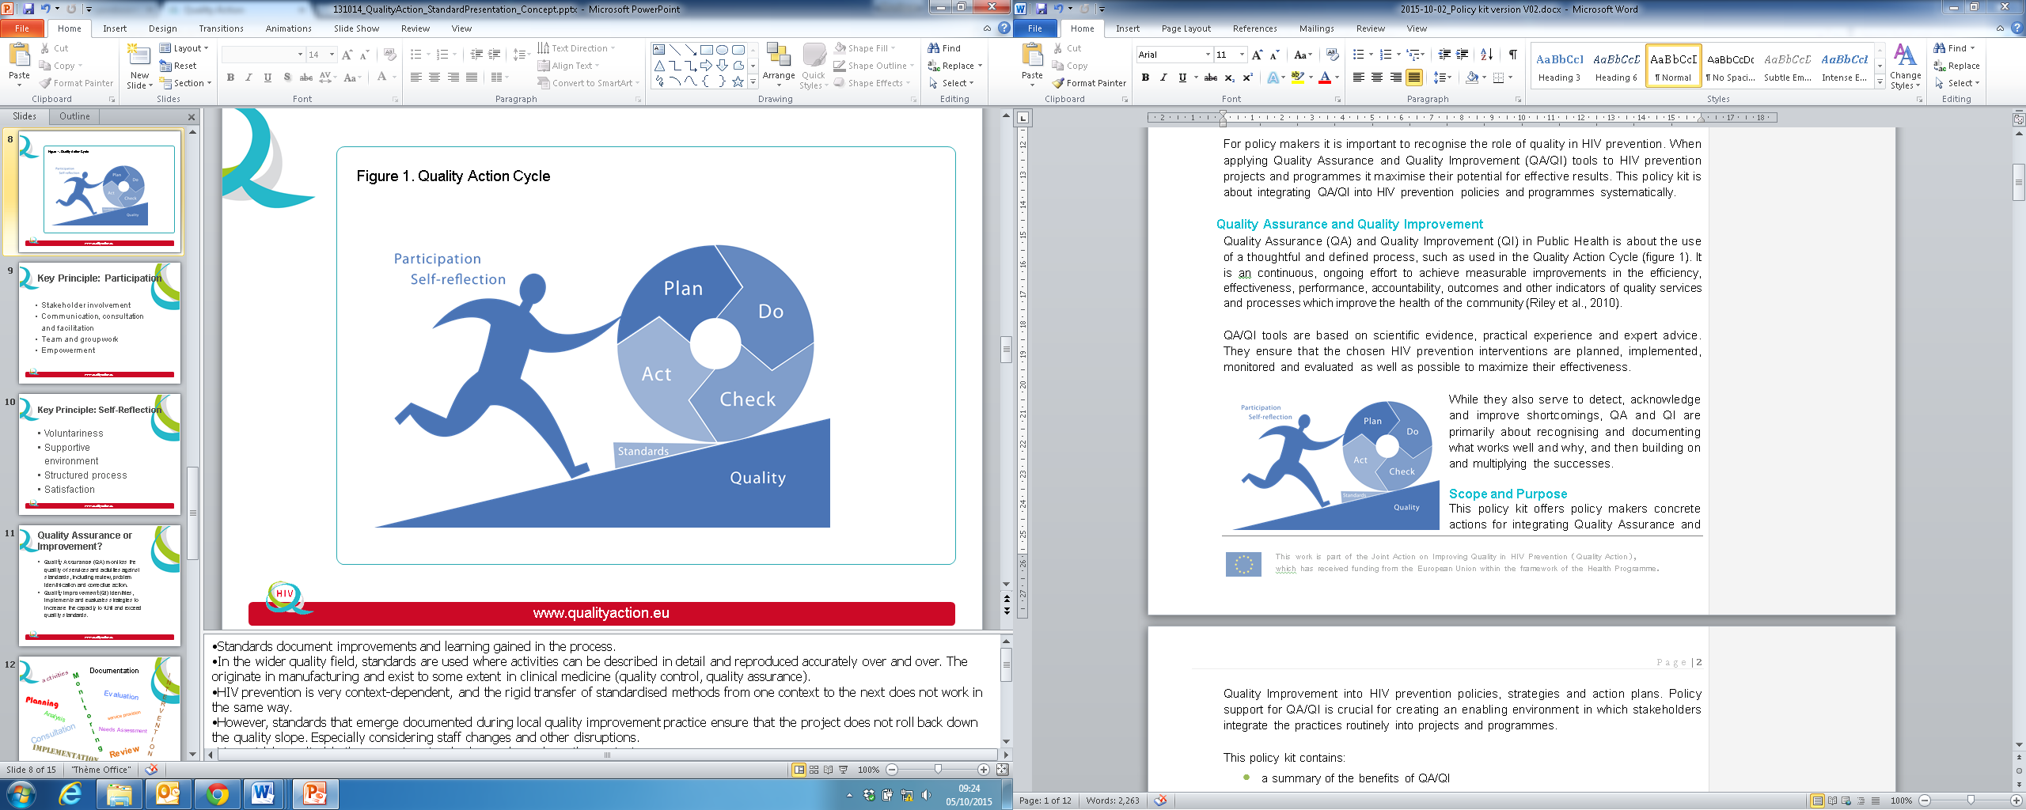

What does it cost?

Quality improvement is a prerequisite for good practice in HIV prevention. There are few costs to be allocated to using the tools and creating an enabling environment for self-reflection and stakeholder participation. Quality Action has already developed practical tools and supporting materials (Fact Sheet: Tools), and trained a European network of experts (Fact Sheet: Quality Acton Network).

‘The findings clearly show that successful quality improvement applications depend on several competencies of their users: being knowledgeable about the tool, facilitation skills, organisational and planning skills. Participants felt they had acquired those skills sufficiently during the training, resulting in self-confidence to be able to apply a quality improvement tool.’
(Quality Action Qualitative Evaluation Report)

Given this modest level of additional investment, Quality Action participants perceived a substantial benefit from applying a quality improvement tool.

This graph shows how participants rated the balance between resources input and outcome of applying a quality improvement tool.

What are the Benefits?

Maximum effect: multiple stakeholder perspectives optimise the quality of interventions: from problem analysis, needs assessment and planning to implementation, monitoring and evaluation.
Extended reach and coverage: targeting interventions based on all available knowledge increases the capacity to reach the most affected populations.

>75% of Quality Action respondents report better targeting, increased reach and greater stakeholder involvement after applying a quality improvement tool.
Quality Action evaluation

Increased efficiency: structured quality improvement makes the most of financial and human resources.

What needs to be done?

Quality Action participants identify 6 key factors that influence the successful integration of quality improvement into HIV prevention practice: 1) selecting the right tool for the project and situation; 2) planning step-by-step; 3) inviting stakeholders with a range of perspectives: 4) skilled facilitation; 5) time, space, meeting costs and 6) support from line managers through to programme leaders and policy makers.

‘You still need the top to support it in order to do the bottom up. If you don’t have the support there, you can’t do it.’
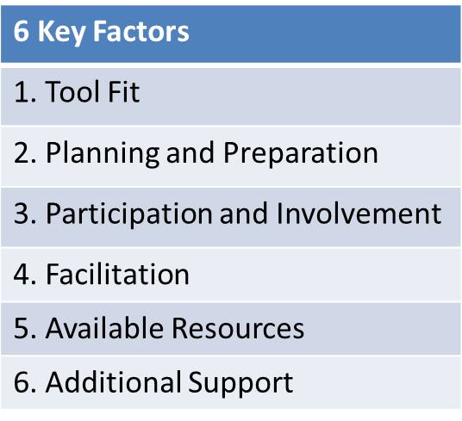
(Quality Action focus group participant)

Regarding point 6), a survey among policy makers in European countries (see ‘Policy Survey’ in this kit) showed that the majority had a strong interest in quality improvement. Five countries have already included references to quality in their national HIV prevention policies (see ’Country examples of policy statements’ in this kit).

- Include quality as a key factor in policy and strategic documents.
- Integrate structured quality improvement into action plans and programmes.
- Offer incentives for regular, practical quality improvement.
- Provide opportunities for learning and exchange.

How can it be done?

Quality Action recommends the following Principles, Aims and Actions for integrating quality improvement into HIV prevention policies, strategies and action plans:

Principles
- Attention to quality maximises the effectiveness of HIV prevention and health promotion interventions.
- Quality improvement tools act on the determinants of successful HIV prevention interventions.

Aim
- To make structured quality improvement an integral part of our HIV prevention and health promotion interventions at all levels.

Actions
- Build an open and collaborative environment among stakeholders in order to multiply successes and learn from failures.
- Regularly conduct self-directed quality improvement activities based on self-reflection and the participation of stakeholders, especially key populations, by using practical quality improvement tools at the project, programme and policy levels.
- Train and support stakeholders to use quality improvement tools at the project, programme and policy levels.
- Provide the resources necessary to support stakeholders to use quality improvement tools regularly (e.g. ‘at least every x years’ or ‘at least once during the life of this action plan’).
- Organise regular opportunities for stakeholders to exchange and discuss lessons learnt (e.g. ‘at least every x years’ or ‘at least once during the life of this action plan’).
- Use the resulting learning strategically to improve projects, programmes and policies.

‘I think that is one result of Quality Action, it goes beyond the tools and the training. Quality Action is about communication of quality, putting quality on the agendas of NGOs, and governmental organizations. I don’t know if it is really a result of the project but during the time of it, I think in 50% of our department it became the standard to apply tools for the improvement in the approach of their project. Of course my colleagues want to and not because they are forced by funders to do so. Really something changed since Quality Action happened.’
Quality Action focus group participant

Further reading

Quality of Care: a process for making strategic choices in health systems, World Health Organization 2006

Meyers D, Durlak J, Wandersmann A. The Quality Implementation Framework: A Synthesis of Critical Steps in the Implementation Process. Am J Community Psychol (2012) 50:462-480

European Centre for Disease Prevention and Control, WHO Regional Office for Europe. HIV/AIDS surveillance in Europe 2014. Stockholm: ECDC; 2015.

European Centre for Disease Prevention and Control, Evidence brief: HIV prevention in Europe. Monitoring implementation of the Dublin Declaration on partnership to fight HIV/AIDS in Europe and Central Asia – 2014 progress report. Stockholm: ECDC; 2015.

Quality Action: Qualitative Evaluation report, 2016, www.qualityaction.eu

Quality Action: Evaluation Report, 2016, www.qualityaction.eu

Quality Action: Practical Application Report, 2016, www.qualityaction.eu

CHARTER FOR QUALITY IN HIV PREVENTION

While there have been some progress made in recent years, HIV prevention continues to play a crucial role in combating the HIV epidemic. To reinforce the effectiveness of HIV prevention within the European Region, Quality Improvement is essential.
Quality improvement consists of systematic and continuous actions that lead to measurable improvements. Quality Action, the EU co-funded Joint Action on Improving Quality in HIV prevention promotes evidence and knowledge based quality improvement tools for HIV prevention.
This Charter states the principles and criteria for quality in HIV prevention and calls on stakeholders to support and apply quality improvement. Not only must approaches, interventions and methods for HIV prevention be appropriate to the situation they address, they must be carried out at a high level of quality to maximise effectiveness.
High quality and successful HIV prevention strategies and interventions require substantial and adequate funding and resources.

In the framework of this Charter we affirm our commitment to the following principles:
Self-reflection  We reflect on our own work as a prerequisite for learning. As learning organisations we encourage professional growth and continuous improvement. | Participation and Collaboration  We foster strong partnerships and collaborations with all our stakeholders, especially priority populations, to achieve positive and lasting change.
Transparency  We act with integrity, honesty and accountability to build trust. | Innovation  We promote new ideas, evidence-based practice and practice-based evidence within our projects, organisations and amongst our stakeholders.
Passion and commitment  We are passionate about quality and will use our enthusiasm to inspire change, innovation, learning and improvement. | Supportive environments  We promote supportive environments, where self-directed quality improvement can be conducted without fear of consequences and where mistakes are seen as opportunities for learning.

Through testing, adapting and implementing practical tools for quality improvement, Quality Action has generated added value for organisations and prevention settings across the diverse economic and political contexts in which HIV prevention takes place.

The project has successfully trained a range of prevention stakeholders resulting in increased knowledge and confidence to apply quality improvement in practice. The following quality criteria for HIV prevention emerge from a review of tools and literature as well as qualitative and quantitative evaluation of practical applications of quality improvement tools carried out by project partners.

We acknowledge these key quality criteria for all phases of prevention work:
Planning/Concept | Structure | Process | Outcomes
Select target groups and assess needs systematically and based on evidence.  Define consistent, specific and realistic goals and objectives.  Select appropriate approaches and methods. | Build organisational commitment.  Allocate sufficient resources.  Build the capacity of staff.  Collaborate with stakeholders and networks. | Continually assess and review implementation quality.  Adapt to changes in the operating environment. | Document reach and acceptability.  Monitor, assess and document results.  Pass on experience and results for sustained improvement.

Based on the above principles and criteria, we aim to increasingly integrate the following actions into our work:

At the project/programme level, we will select suitable quality improvement tools, apply tools regularly to all phases of the project cycle and involve stakeholders - especially key populations – as well as document, share and act on the results.

At the organisational level, we will further integrate quality improvement into organisational structures and processes by allocating time and resources to regular quality improvement, training staff, providing access to expert networks, reviewing learning from quality improvement at the organisational level and creating a supportive environment for reflection and learning.

At the policy level, we will further integrate quality improvement into policies, strategies and action plans. We will promote quality improvement activities as standard practice and support networks by providing opportunities and resources for regular capacity building and exchange of results and learning in quality improvement.

This Charter was created by the representatives of Quality Action. You can support it by becoming a signatory as an organisation or as an individual at www.qualityaction.eu.

Quality Action offers five practical tools adapted or developed for HIV prevention to suit a wide range of projects and programmes. They are based on scientific evidence, practical experience and expert advice. All tools improve self-reflection and participation and create a culture of quality assurance and improvement. They are complemented by a tool selection guide, a facilitation guide, training materials and online learning resources (www.qualityaction.eu).
FACT SHEET: TOOLS

Criteria used to select and develop tools for the project:
Knowledge based - on published research or documented best practice;
Evaluated - documented evaluations proving that the tool works;
Suitable for HIV Health Promotion and Prevention - key elements and common concepts and language of the international HIV response integrated;
Practical and user-friendly format.

The tools used in Quality Action consist of questionnaires, scoring forms, participatory methods and facilitation guides. Please find short descriptions and excerpts below. More detailed fact sheets on each tool and its supporting materials are available at www.qualityaction.eu.

‘One of the main advantages of these tools is to have an approach to self-reflect on projects you are doing and it helps colleagues to do the self-reflection on their projects.’
Quality Action focus group participant

The great majority of Quality Action respondents rated the tools positively in terms of user-friendliness, length and language level. All tools were further revised on qualitative evaluation results.
Quality Action Evaluation

Succeed

Succeed is a self-guided self-assessment tool designed for use at the project level. It is particularly useful for projects with limited experience in quality improvement approaches. The tool is built on 13 success factors and divided into three: Structure, Process and Results. Summaries for each section document improvement actions.

Link to the tool: www.qualityaction.eu

Quality in Prevention (QIP)

QIP is a self-guided, externally assessed tool designed for use in projects. Users fill in a documentation form, which is then assessed by at least three trained expert reviewers. Projects receive scores on defined quality dimensions from the reviewers as well as specific written recommendations for improving the project.

Link to the tool: www.qualityaction.eu

Participatory Quality Development (PQD)

PQD is built on local knowledge, local theory, target group orientation, participation and collaboration. It contains theory and a toolkit with detailed instructions for 11 participatory methods for all phases of the project cycle. The methods are tailored, feasible, participatory and evidence based.

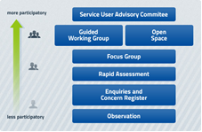

Link to the tool: www.pq-hiv.de/en

PIQA: Quality Assurance for HIV Prevention Projects for People Who Inject Drugs (PWID)

PIQA is a self-guided self-assessment tool to assess the quality of prevention interventions for PWID specifically. The tool uses a scoring form that shows strengths and weaknesses for seven aspects: 1) Analysis, 2) Determinants, 3) Objectives, 4) Interventions, 5) Implementation strategy, 6) Evaluation and 7) Contextual conditions. Improvements are documented at the end of each section.

Link to the tool: www.qualityaction.eu

Shift

Shift is a facilitated self-assessment tool for national and other multi-component prevention programmes. It consists of a 20-page questionnaire with assessment scales, a Population & Programme Worksheet, a template for Stakeholder Snapshots and an extensive Methodology Guide for conducting the facilitated stakeholder meeting that is at the core of the tool.

Link to the tool: www.qualityaction.eu

Selecting quality improvement tools
These five tools differ in the level of stakeholder participation, resources and time needed. The Quality Action Tool Selection Guide assists with matching tools to user needs, e.g. size, timing, team, stakeholders and expected results. (www.qualityaction.eu).

65% rated the Tool Selection Guide ‘very helpful’ and 35% rated it ‘helpful’.
Quality Action evaluation

‘It would be good if I could pass the knowledge of this tool further and people
could apply it to their working field to have a systematic way of assessment of these projects. But again we will have to have an acknowledgment and support of lead management to do something like that.’
Quality Action focus group participant

FACT SHEET: QUALITY ACTION NETWORK

Quality Action has trained more than 400 quality improvement trainers and facilitators from 25 different European countries. They form a network based on a culture of continuous improvement in HIV prevention, multidisciplinary collaboration and exchange of knowledge, skills, and expertise across organisations and countries.

EU-level trainees: 105 (60% NGO and 40% GO)
National-level trainees: >300

These experts can train others and provide technical assistance in a range of contexts. Quality Action provides training materials, an online training resource and a facilitation guide to support the train-the-trainer approach.

A complete list of countries, organisations and tool experts is available at www.qualityaction.eu. The next section shows the range of tools that the trained experts can support and the range of interventions and target populations covered by their expertise.

Coverage of tools, key populations and interventions
EU-level training: tools trained
Distribution of EU-level trainees across the five Quality Action tools (Quality Action evaluation)

EU-level Quality Action trainees applied quality improvement tools to a wide range of HIV prevention projects targeting all relevant priority groups.
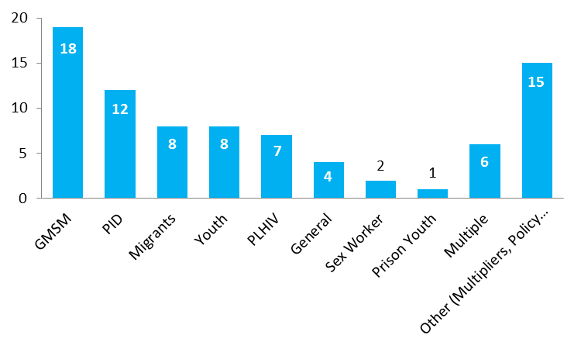

Number of HIV prevention projects/programmes participating in Quality Action by targeted key population (Quality Action Practical Application Report)

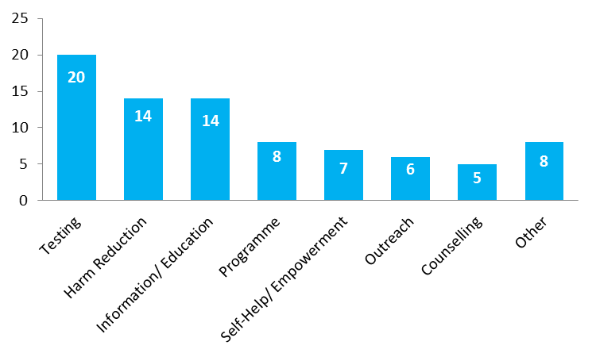

Number of HIV prevention projects/programmes participating in Quality Action by type of intervention (Quality Action Practical Application Report)

Using quality improvement tools in practice: case studies

The Quality Action website offers a searchable database of case studies covering all five Quality Action tools, GO as well as NGO implementers and a range of relevant key populations and intervention types.

Quality Action in Europe

The following map shows countries currently represented in the Quality Action network. An interactive version showing tools, experts and contact points per country is available at www.qualityaction.eu

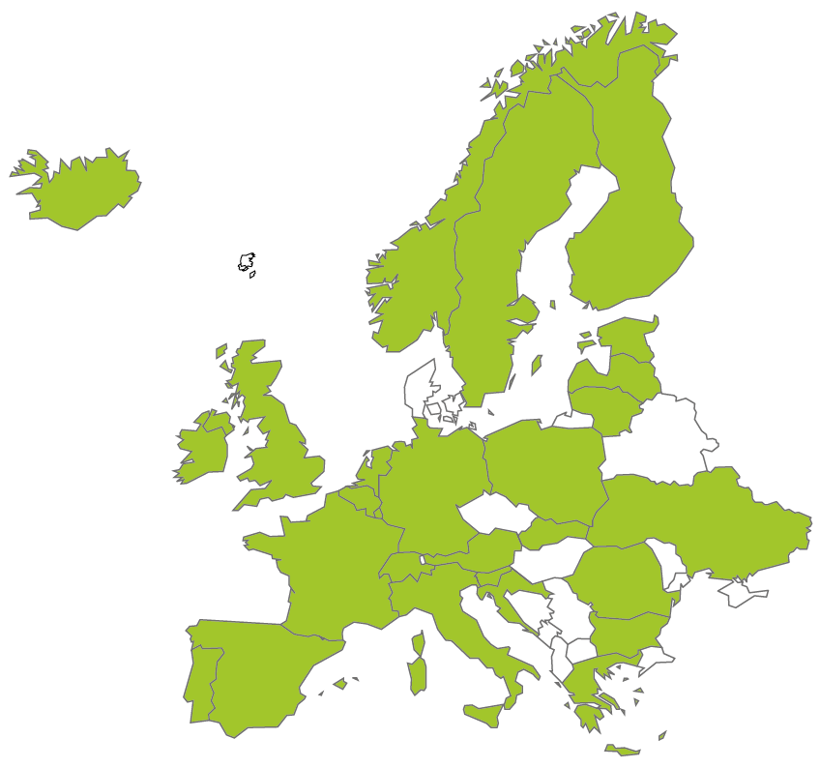

‘It is not just about the training but about the networks. Because the networks are how you do it - the interaction, sharing, meeting face to face. The networking helps us to have high standards throughout Europe and that is the important thing’.
(Quality Action training participant)

Glossary

Term | Definition
Activities | Actions taken to achieve goals and objectives.
Aims / Goals | The results we are trying to achieve; a goal is the terminal point or what you aspire to do; organisational goals are strategic and SMART (Specific, Measureable, Attractive, Realistic and Time bound).
Capacity Building | Increasing the ability of a person, group or organisation to perform certain tasks or respond to certain situations; includes increasing knowledge and skills as well as changing perceptions, attitudes and behaviours.
Charter | A document listing basic norms that are agreed across boundaries.
Epidemiology | Study of the causes and distribution of infections, diseases or health problems in populations and the application of this study to their control.
Epidemiological data | Statistical information about the incidences and distribution of HIV (surveillance); analytical and behavioural studies on health determinants, health promotion and HIV prevention.
Evidence | Often published in peer-reviewed journals and generated according to scientific standards, often using randomised control trials, with a focus on quantifiable, measurable effects; may change in light of new evidence (see practice-based evidence).
Evidence-based practice | Choosing the approaches, interventions and methods most appropriate to a given situation and implementing them at the highest possible level of quality; traditional scientific evidence is not always available or conclusive, especially for structural, social and behavioural interventions; a lack of availability of what is regarded as scientific evidence does not mean an approach or method is ineffective, nor should it stifle innovation; in addition to scientific evidence, other forms of knowledge are valuable, such as local cultural knowledge and practice-based evidence.
Goals / Aims | The results we are trying to achieve; a goal is the terminal point or what you aspire to do; organisational goals are strategic and SMART (Specific, Measureable, Attractive, Realistic and Time bound).
Key populations | Those people at higher risk of infection and to involve in the response (people living with HIV are also a key population in HIV prevention); distinct from, but may also include, vulnerable and at risk populations; those who are disproportionally at risk of contracting HIV are identified by the WHO as men who have sex with men, transgender people, people who inject drugs, sex workers and people in prisons and other custodial settings.
Kit | A set of useful tools, instruments or other practical components that are combined in order to assist with carrying out a particular task or to serve a particular purpose.
Objectives / Sub-goals | Shorter (than aims / goals) term measureable targets to achieve the long term or strategic goal.
Participation (a key principle of Quality Action) | Important as no single point of view can give an accurate picture of the context in which a HIV prevention activity operates; target group participation is especially significant and a key element of the Quality Action tools; if the project/programme does not respond to the needs and context of the target groups it is less likely to be effective; involves stakeholder involvement, communication, consultation and facilitation, team and group work, and empowerment.
Practical Application | The use of an approach, theory, tool, instrument or process in the course of ordinary, day-to-day professional practice (in this case practically applying the tools to HIV prevention projects / programmes / activities).
Policy | An agreed or imposed direction governing action in a certain area; it can apply to and be enforced in a particular jurisdiction (such as a nation, state, region, county, or municipality) or self-imposed as a more or less binding guideline by any organised group of people (institution, NGO, club or association).
Practice-based evidence | Derives information on the effectiveness of interventions from the structures and logic of the practical work; indications for the effectiveness of interventions are tested in a particular context, at a particular point in time and at a particular location; this localising of evidence has the potential to produce new insights which can be immediately integrated into practice and contribute to a process of on-going improvement; evidence and practice inform each other in a continuous cycle of quality improvement (see evidence-based practice).
Programme | Combinations of interventions and/or activities that work together to achieve a change in health status such as reducing new HIV infections; examples are national or regional HIV prevention action plans or a comprehensive service (e.g. incorporating testing, counselling, outreach, needle exchange and condom distribution).
Project | A single intervention with a beginning and end or regular cycles (e.g. a health promotion campaign or an outreach intervention); projects are usually designed to influence a particular determinant of health (e.g. increasing health knowledge or improving access to condoms and lubricant).
Quality | Achievement of desirable goals in health outcomes in a manner consistent with current professional knowledge and standards.
Quality Improvement (QI) | Quality improvement formally identifies, implements and evaluates strategies to maximise the potential of an activity, including increasing its capacity to fulfil and exceed quality standards. It can be used at any stage of an activity and always aims for improvement, no matter what the starting point is.  Quality Improvement may include quality assurance, which formally monitors the quality of services and activities against standards (where they exist), including review, problem identification and corrective action. Quality assurance processes are particularly suitable where standardised services are offered, such as medical and clinical procedures (e.g. testing and counselling).  Quality improvement highlights what we are doing well while offering clear steps to improving quality, aims to ensure that decisions about what to do and which methods to use are based on the best available evidence, knowledge and experience, and ensure that the chosen activities are planned, implemented, monitored and evaluated to maximise their potential affect.
Self-reflection (a key principle of Quality Action) | Stepping back to critically examine how well our efforts actually work; reflections are rarely structured, rarely look at all aspects of a project/programme, rarely include all relevant stakeholders, are rarely documented and rarely lead to systematic changes; rigorous self-reflection is a prerequisite for improving quality because the assumptions we protect most fiercely are often the most rewarding to question; cannot be imposed by or on others; it is a voluntary process which may require courage and a supportive environment; important to document that we have and will continue to do our best with our interventions.
Stakeholder | A person representing a group or organisation with an interest in a particular activity; the interest may arise from having responsibility for, actively contributing to, benefitting from or being impacted by the activity.
Standards | Set of criteria against which an intervention is compared or measured; normally based on general consent or established by custom or authority as being the benchmark for quality; in the wider quality field they are used where activities can be described in detail and reproduced accurately and repeatedly; HIV prevention is very context-dependent and the rigid transfer of standardised methods from one context to the next may not work in the same way; standards that emerge during local quality improvement practice can be documented to provide practice-based evidence; they may be specific to an individual project or they may be useful for a particular method across a range of contexts or for a variety of methods within a single context.
Target groups | Those who serve as the focal point for a particular project/programme; two categories (some people may belong to both) - beneficiaries (those you directly want to target) and intermediaries (those you involve in the project/programme because they can effectively reach the beneficiaries); may convey a non-participatory or top-down approach (participation is a key principle of Quality Action).
Tool | We use the word “tool” to describe a structured, documented approach to quality improvment using a practical, step-by-step process. Tools can be paper-based or electronic and often consist of:  - check lists  - questionnaires  - facilitation guides for stakeholder input
Vulnerable populations | Those who are more vulnerable to HIV in specific situations or contexts, such as societal pressures or social circumstances; includes migrants, adolescents or prisoners.

Appendices

Current approaches to quality improvement in HIV prevention in European countries

To assess if national HIV prevention policies contained quality improvement criteria and if there are any future plans to introduce recommendations for integrating quality improvement approaches into HIV prevention policy, an email survey in 30 European countries was performed between May and July 2014.

In total, nineteen countries completed the questionnaire (response rate 63.33%). All countries reported to have an official policy for HIV prevention but only eleven (57.9%) reported to included QA/QI criteria in their HIV prevention policies. Fourteen (73.7%) countries are reviewing their national HIV prevention strategies, of which 11 (79%) are likely to include recommendations around QA/QI in their policy. Finally, sixteen countries (84.2%) out of the nineteen countries responded to the questionnaire are interested in receiving support to include QA/QI in their policies.

Quality Action concludes that European countries show a strong interest to improve HIV prevention activities using quality improvement criteria and tools. These data underpin the development of a policy toolkit to encourage the wider dissemination of quality improvement tools criteria. Therefore, we recommend quality improvement criteria and tools should be embedded in HIV prevention activities as an integral part.

Quality Improvement statements in five national HIV prevention policies

Five European countries have already included quality improvement recommendations in their HIV prevention policies.

Germany
The quality of government and non-government prevention measures for HIV/AIDS is continually monitored in order to ensure their effectiveness.

The effects of strategies against HIV/AIDS must be measurable. Regular studies and assessments are prerequisites for adapting strategies to changing social conditions on a scientific basis.

Evaluation and quality assurance are especially indispensable when developing targeted prevention measures for new groups.

Link to the original document:
http://www.bmg.bund.de/fileadmin/redaktion/pdf_broschueren/Aktionsplan-HIV_Aktionsplanv-HIV-Aids-deutsch.pdf (see page 44)

Ireland
Quality Improvement and Quality Assurance tools will be implemented in line with the Europe-wide Joint Action on Quality, Quality Action. National sexual health service performance indicators and mechanisms for their assessment will be developed and implemented.

Spain
Quality Improvement and Quality Assurance are described in recommendation 4.8) “Develop and validate methodological tools for quality control in prevention programmes along the lines of the European Joint Action on "Improving quality in HIV prevention" (Strategic Plan for Prevention and Control of HIV infection and other Sexually Transmitted Infections 2013-2016).
Furthermore, Quality Improvement and Quality Assurance are one of the recommendations in chapter 7; goal 4: Reduce the incidence of HIV infection and other STIs. Page 166

Link to the original document:
http://www.msssi.gob.es/ciudadanos/enfLesiones/enfTransmisibles/sida/docs/PlanEstrategicoPrevencionControlVIHITS2013_2016.pdf

Slovenia
In the existing national HIV infection prevention and control strategy for 2010-2015 Quality Improvement and Quality Assurance are not directly mentioned in relation to HIV prevention programs, although quality is explicitly mentioned multiple times.
Slovenian stakeholders are currently preparing a new HIV strategy for period 2016-2021 which will contain evidence based and comprehensive approaches, new terminology and explicitly mentioned Quality Improvement and Quality Assurance not only in HIV prevention but in aims of all pillars of the new Strategy.

Link to the original documents:
- http://www.mz.gov.si/en/areas_of_work/public_health/control_of_communicable_diseases/hivaids/#c17648
- HIV Infection Prevention and Control Strategy for 2010-2015

Norway
The statement is extended for one year.
Link to original document:
https://www.regjeringen.no/globalassets/upload/hod/dokumenter-fha/acceptance-and-coping-national-hiv-strategy.pdf

